**The Scale of the Universe sec.1**

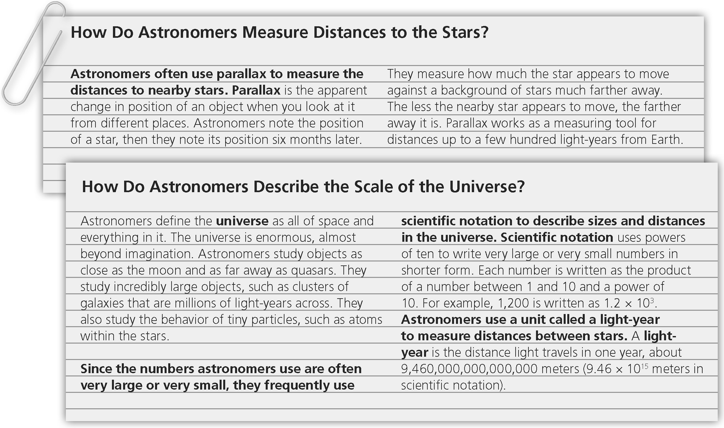

**Star Systems and Galaxies sec.2**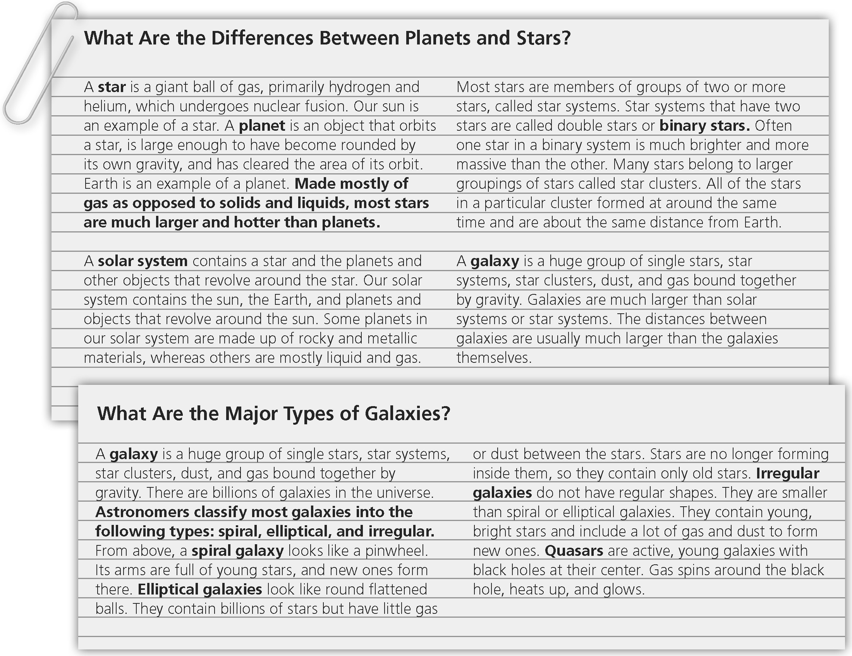

**Gravity and Motion sec 3**

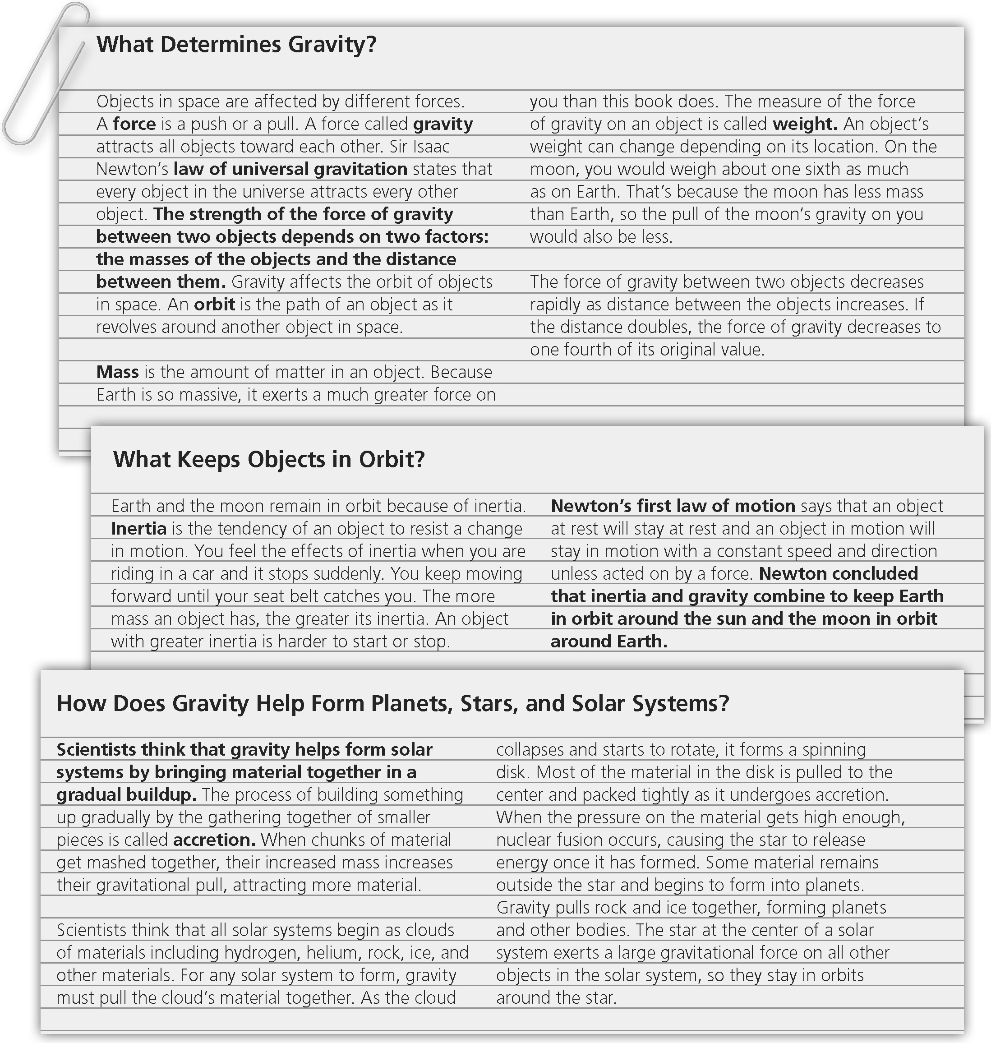

**Characteristics of Stars sec 4**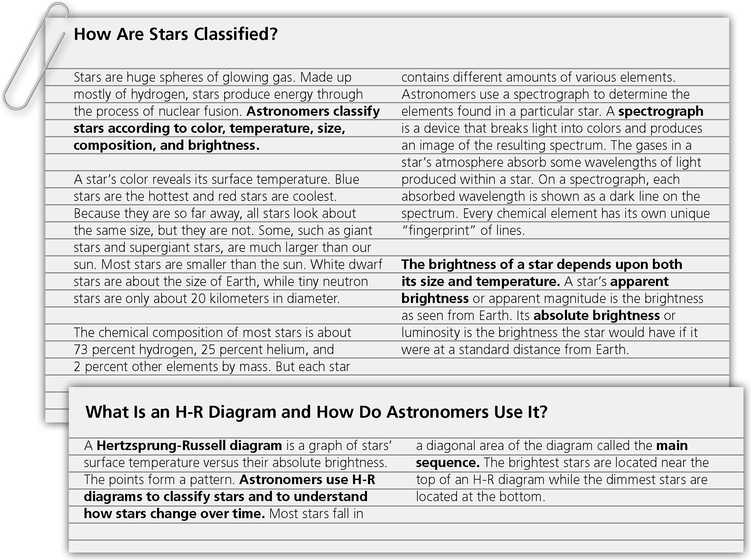

**Lives of Stars sec. 5**

